AP Art History: Packet 2

Aegean Art:

* + Reflection of life (carefree in the case of the Minoans, militaristic in the case of the Mycenaeans) exemplified in the subject matter and style of art

Greek Art:

* + Emphasis on self-knowledge and moderation (sophrosyne) as opposed to arrogant pride and excess (hubris)
  + Concept of aesthetics (appreciation of beauty) based on mathematical proportions
  + Concept of “Man” as the “measure of all things”
  + Emphasis of balance between intellect and feeling (worship of both Apollo and Dionysos is applicable here)

Vocabulary:

Labyrinth – “labrys” means “double ax” (recurring motif in the palace referring to sacrificial slaughter; intricate plan and scores of rooms of the Knossos palace

Zoomorphic – attribution of animal characteristics or qualities to a god, use of animal forms in symbolism, literature

Stoas – covered colonnades, porch, meeting place

Barbotine decoration – a paste of clay used in decorating coarse pottery in relief

Polychromatic – exhibiting many colors or a change in colors

Corbel – a projecting wall member used as a support for some element in the superstructure, also, courses of stone or brick in which each course projects beyond the one beneath it, two such walls, meeting at the topmost course, create a corbelled arch or corbelled vault

Tholos – beehive shaped tombs covered by enormous earthen mounds

Dromos – long passageway (into the tholos)

Repousse – formed in relief by bearing a metal plate from the back, leaving the impression on the face. The metal is hammered into a hollow mold of wood or some other pliable material and finished with a graver (an incising tool)

Amphora – a two handled jar used for general storage purposes, usually to hold wine or oil

Krater – bowl for mixing wine and water

Symposium – a convivial (social) meeting for drinking music, and intellectual discussion among the ancient Greeks

Kouros – youth

Kore – a sculpture representing a standing young woman clothed in long robes, (also daughter of Zeus)

Encaustic – painter mixed the pigment with wax and applied it to the statue while hot

Acropolis – “high city”

Stylobate – the immediate foundation of a row of classical columns

Pediment – in classical architecture, the triangular space (gable) at the end of a building, formed by the ends of the sloping roof above the colonnade (a series or row of columns, usually spanned by lintels (a beam used to span an opening)

Entablature – the part of a building above the columns and below the roof, classical temple, has three parts: architrave or epistyle (the lintel or lowest division of the entablature)

Frieze – between the architrave and the cornice, any sculptured or painted band in a building and pediment

Naos – cella, a room with no windows that usually housed the cult statue of the deity

Pronaos – the space, or porch, in front of the cella, or naos, of an ancient Greek temple

Peristyle – external colonnade on all four sides

Doric order – massive in appearance, sturdy columns firmly planted on the stylobate

Golden Mean – divine ratio (1.618) the proportional relation between two divisions of the line or two dimension of a plane/ figure such that smaller is the larger as the larger is to the sum of the two, A + B = 1.618, happy medium

Metope – the panel between the triglyphs (a triple projecting, grooved member of a Doric frieze that alternates with metopes) in a Doric frieze, often sculpted in relief

Cornice – the projecting, crowning member of the entablature framing the pediment; also any crowning projection

Entasis – the convex profile (an apparent swelling) in the shaft of a column

Black-figure technique – painter first put down black silhouettes on the clay surface, then used a sharp pointed instrument to incise linear details within the forms, usually adding highlights over the black figures before firing the vessel

Ceramics – the art of making the decorating pottery

Slip – liquefied clay, glue for clay

Red-figure technique – (artist – Andokides Painter) instead of using the glaze to create the silhouettes of figures, the painter outlined the figures and the colored the background black, the artist could vary the glaze thickness there by expanding the chromatic range

Firing – to bake ceramics in a kiln (brick lined oven), high temperatures (@ 2000 degrees)

Oxidation – the combination of a substance (clay) with oxygen in the firing process

Bilingual vase – experimental vases with the same composition painted on both sides, once in black-figure and once in red-figure

Contrapposto – the disposition of the human figure in which one part is turned in opposition to another part (usually hips and legs one way, shoulders and chest another), creating a counter positioning of the body about its central axis. Sometimes called “weight shift” creating tension on one side and relaxation on the other, separates Classical from Archaic Greek statuary.

Cire perdue – hollow-cast statues lost wax method, several steps, repeated many times, monumental statues cast in parts

Ionic order – characterized by among by volutes (a spiral, scroll like form), capitals, columns with bases, uninterrupted frieze, base

Sophrosyne – “moderation” – refers to the avoidance of excess in daily life

Hubris – common theme in Greek tragedies and mythology, individuals “tragic flaw” usually thinking they were equal or greater than the gods, subsequently being punished, overbearing pride or presumption

Caryatid – a sculptured female figure serving as an ornamental support in place of a column or pilaster

Orchestra – a semicircular space in front of the stage used by the chorus, “dancing place”

Theatron – place for seeing, where spectators sat on a slope overlooking the orchestra

Corinthian column – more ornate, Kallimachos invented, all four sides are similar in appearance, it does not need to be modified, Ionic frieze is used here thus architects do not have to contend with metopes or triglypths

Pebble mosaics – (pella mosaics), the floors are formed of small stones of various colors collected from beaches and riverbanks and set into a thick coat of cement

Tesserae -tiny stones or pieces of glass cut to the desired size and shape (instead of pebbles)

Hellenistic Art – violent movement, swirling draperies, and vivid depictions of death and suffering are the norm, emotional intensity, baroque (synonym for absurd or grotesque), overtly sexual

Gigantomachy – the battle between gods and giants

Pathos – a quality, as of an experience or a work of art that arouses feelings of pity, sympathy, tenderness, or sorrow

AEGEAN ART

CYCLADIC

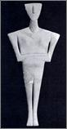

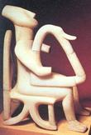

Cycladic female figurine (Syros) c. 2500-2300 BCE, marble

* + Cycladic
  + neolithic statues
  + schematic figures

MINOAN

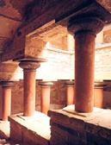

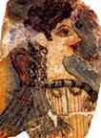

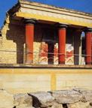

Palace of Knossos c. 1700-1400 BCE

* + Arthur Evans
  + King Minos and Pasiphae
  + Theseus and the Minotaur
  + central court
  + unfortified
  + system of terracotta pipe
  + wet or buon fresco

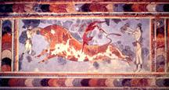

Toreador Fresco (Knossos) c. 1450-1400 BCE

* + bull leaping
  + elongation
  + depiction of woman

* + 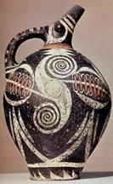

Kamares Ware jar (Phaistos) c. 1800-1700 BCE

* + love of nature and the sea
  + zoomorphic motifs
  + Barbotine decoration
  + Polychromatic
  + 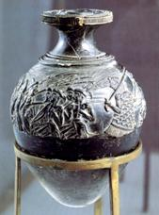

Harvesters Vase c. 1500 BCE, steatite

* + winnowing fans
  + static repetition shunned
  + interest in muscular and skeletal structures

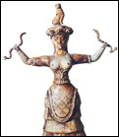

Snake Goddess (Knossos) c. 1600 BCE

* + exposure of breasts
  + use of snakes

MYCENAEAN

Machine generated alternative text: -
b
V.- 41

Lion Gate (Mycenae) c. 1300-1250 BCE, limestone relief

* + cyclopean structures
  + relieving triangle
  + corbelling
  + 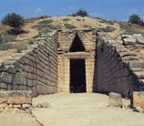

Treasury of Atreus (Mycenae), c. 1300-1250 BCE

* + tholos (beehive tomb)
  + dromos

Funerary Mask (Grave Circle A, Mycenae)

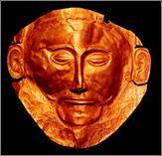

c. 1600-1500, beaten gold

* + Henrich Schliemann
  + repousse
  + life-size proportions
  + 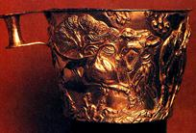

Vaphio Cups (Vaphio) c. 1500 BCE, gold

* + evidence of Mycenaean and Minoan trade and contact

Warrior Vase (Mycenae) c. 1200 BCE

* + krater
  + same pattern repeated without variety and detail
  + compared to the Harvesters Vase

GREEK

GEOMETRIC PERIOD

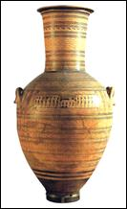

Dipylon Master. Dipylon Vase c. 750 BCE

* + use for funerary ceremony and or use as an amphora at a symposium
  + angular motifs (meander pattern)
  + abstract, simplified figures, amphora
  + signed by Dipylon Master
  + three and half feet tall
  + grave marker
  + held mixture of water and wine
  + symposium-male drinking party
  + registers
  + bodies configured of geometric forms

GREEK ORIENTALIZING PERIOD

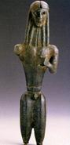

Mantiklos Apollo (Thebes) c. 700-680 BCE

* + “The Healer”
  + stylized triangular torso
  + exposure to Eastern art through trade
  + inspired by trade with Egypt and Syria

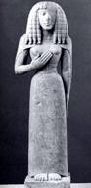

Lady of Auxerre c. 650-625 BCE

* + Daedalic style-mass production
  + fondness for pattern
  + gesture of prayer
  + encaustic-wax mixed with pigment

|  |  |
| --- | --- |
|  |  |
|  |  |

GREEK ARCHAIC PERIOD

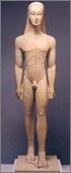

Kouros (Attica) c. 600 BCE, marble

* + liberation from the block of stone (compared with Egyptians)
  + appearance of the nude
  + traces of Orientalizing period still remaining
  + use of statuary as a grave marker
  + kouros-young male
  + life sized
  + almost all have stylized hair; realistic bodies
  + from this point on, males are portrayed nude- Athenians wanted to be different, decided to create nude scenes; physical strength equals power
  + used for grave markers

* + 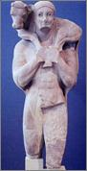

Calf-Bearer (Moschophoros) (Athens) c. 560 BCE, marble

* + suggestion of noble perfection in a scene of sacrifice
  + “Archaic smile”
  + increased naturalistic rendering
  + smile made statues seem more life like
  + found close to Parthenon
  + wet drapery-term for when clothes seems to stick to human form

|  |  |
| --- | --- |
|  |  |
|  | Machine generated alternative text: |

Kore from Athenian acropolis c. 510 BCE, marble

* + chiton
  + Kore
  + Women have clothing
  + Barely above slave in social status
  + Only courtesans could have an education

Temple of Hera (Paestum) c. 550 BCE

* + stylobate
  + cella
  + entablature (architrave, frieze, and pediment)
  + pediment
  + pronaos
  + metopes and trigylphs
  + Doric order
  + love of proportion and numerical relationships (Golden Mean)
  + entasis
  + housed cult statue of worshipped god/goddess
  + can enter temple from all four sides
  + fluted
  + used drums
  + stone and marble
  + Temple Hera II has a pediment

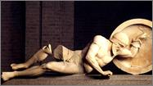

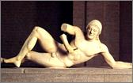

The two Dying Warriors Temple of Aphaia east: c.490-480 BCE; c. 500-490 BCE

* + Battle of the Greeks and the Trojans
  + development of a “Classical” figure
  + right picture-has archaic features such as smile and hair
  + body posture and emotion do not covey message of death
  + left picture-more realistic posture; calm and serene

* + 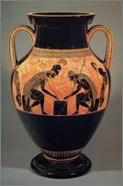

Exekias. Ajax and Achilles playing a game (Vulci) c. 540-530 BCE

* + Exekias, Achilles and the slave girl
  + black-figure technique
  + three-phase firing process: oxidizing, reducing, and reoxidizing
  + engobe (or slip), kiln
  + linear painting style
  + amphora
  + very decorative

* + 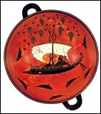

Exekias. Dionysos in a Sailboat c. 540 BCE

* + Dionysos
  + Kylix-drinking glass
  + comparison with decoration of Geometric style amphoras
  + etruscans are pre-roman; link greeks and romans; supposed devil worshippers, evil, etc.
  + captured Dionysos; he grew giants vines of grapes; grew scared, jumped overboard, and turned into dolphins
  + 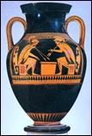

Andokides Painter. Ajax and Achilles playing a game, c. 525-520 BCE

* + red-figure technique
  + same story as black-figure technique
  + realism takes over decorative
  + 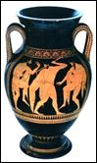

Euthymides. Three Revelers (Vulci) c. 510 BCE

* + attempted foreshortening-looking like art appears to “come out”
  + red-figure

|  |  |
| --- | --- |
|  |  |
| Machine generated alternative text: |  |

Onesimos. Girl going to wash (Chiusi) c. 490 BCE

* + genre scene-everyday life
  + nude female
  + kylix
  + possibly for personal use
  + forshortening

GREEK CLASSICAL PERIOD

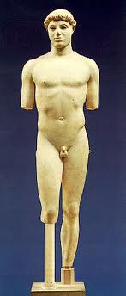

Kritios Boy (Athens) c. 480 BCE, marble

* + contrapposto-weight shift
  + sophrosyne(inner restraint) and hubris(pride) (emphasis of calm and reason)
  + fancier and more realistic hair
  + classical period lasted for 160 years
  + began with Athenians defeating Persians in 479
  + moderation
  + possibly a grave marker
  + natural and realistic
  + physical strength equals power
  + cire purdue-clay, wax, clay; melt wax, pour bronze, and let it harden

* + 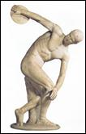

Myron. Diskobolos c. 450 BCE

* + Olympic games (pentatholon); started in 776 BCE
  + naked contestants; along with spectators
  + realization of the idealized human form and universal ideals
  + intersecting arcs
  + stump lets people know it is a roman copy
  + Insects everywhere; hard to find drinking water or food; had to stay in seats
  + Broad jump, discus, sprint, and wrestling
  + Winners received a laurel wreath and a goat
  + Intense contrapasso

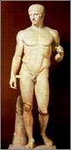

Polykleitos. Doryphoros c. 450-440 BCE

* + Canon of Polykleitos-about sculpting perfect human figure
  + harmony of opposites (rhythmos and symmetria)
  + four stages of man in Greek life-16, started school; 18, went to military; 19, front lines; 21, could leave army, became legal citizen

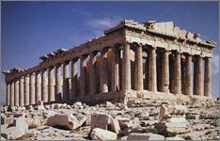

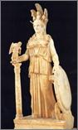

Iktinos and Kallikrates. Parthenon (Athens acropolis) 447-438 BCE

* + Athena-temple whom Parthenon is dedicated too; statue made of ivory and gold
  + The Persian Wars and the Delian League
  + Pericles-patron
  + Acropoli
  + destruction in 1687
  + illusion of uniformity and stability
  + use of the Ionic order in the cella
  + Panathenaic processio
  + east pediment: birth of Athena
  + west pediment: contest of Poseidon and Athena
  + Use of math to determine proportions and what not
  + Roof was tile, either ceramic or marble
  + Entasis-added a bulge to columns so they looked perfect to human eye

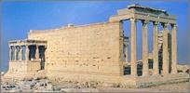

Erechtheion (Athens) c. 421-405 BCE

* + Caryatids-female columns
  + irregular plan
  + Contest between Athena and Poseidon
  + Part of the Acropolis
  + Entrance to Parthenon
  + Kallikrates-architect
  + Ionic columns
  + First building to use solely ionic columns
  + Fluted and engaged
  + Only accessible through the front because of irregular plan
  + Dedicated to Erechtheus, legendary King of Athens
  + 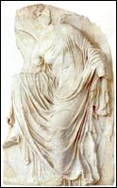

Temple of Athena Nike (Athens) c. 427-424 BCE

* + Nike
  + use of drapery to define anatomy and movement of the figure
  + Only a cella
  + Athena depicted as goddess of victory and war
  + Originally marble
  + High relief
  + Made without wings so she couldn’t leave city

|  |  |
| --- | --- |
|  |  |
|  | Machine generated alternative text: |

Grave stele of Hegeso c. 410-400 BCE

* + depictions of the deceased
  + role of women in Greek society
  + Five feet tall
  + A calm and serene genre scene
  + A servant is giving her master jewelry to pick out

LATE CLASSICAL

Peloponnesian War starts Late Classical period when Spartans attack Athens

Machine generated alternative text: I:”
Ç b
II r1 

Praxiteles. Aphrodite of Knidos c. 350-340 BCE

* + appearance of the female nude in Knidos
  + increased focus on the individual
  + Hydria
  + Six feet, eight inches tall
  + Praxtilean curve-a shallow S-shape
  + Roman copy of an original greek bronze
  + Canon for female sculpture
  + Heavy-set women were more fertile, and meant wealth to afford food
  + Modest, serene, calm
  + 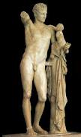

Praxiteles. Hermes and the Infant Dionysos c. 340 BCE

* + Hermes (and a herm statue)
  + prototype of the Good Shepherd
  + sinuous, shallow S curve
  + tender human interactions
  + Roman copy
  + Prototype of the Good Sheppard
  + 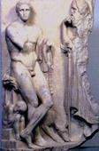

Grave stele of a young hunter c. 340-330 BCE

* + emotional mood (pathos)
  + Five feet tall
  + Classical and hellenistic features

Lysippos. Weary Herakles c. 320 BCE

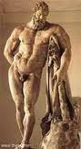

* + Lysippos, Alexander the Great’s favorite
  + attributes of Herakles
  + rejection of stability and balance
  + expression of dejection
  + Idealization
  + Roman marble copy of an original greek bronze
  + After his 12 labors, he is no longer calm and serene, but tired
  + Exaggerated muscle development
  + 10 feet tall
  + 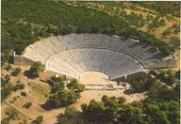

Polykleitos the Younger. Theater at Epidauros c. 350 BCE

* + three days of drama
  + orchestra
  + theatron open to the sky
  + the chorus and actors wearing masks
  + focus on fate (man in conflict with the gods)
  + Only men acted, women weren't allowed
  + Sexual and violent scenes were performed offstage and could only be heard
  + Winners won a goat
  + Tragedy means goat song in ancient greek

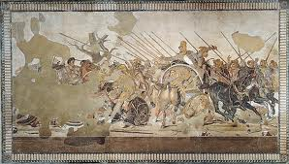

Philoxenos of Eretria. Battle of Issus

c. 310 BCE (Roman mosaic copy)

* + Tesserae-cut stone and glass
  + cast shadows
  + the Battle of Issus
  + Alexander the Great and Darius III
  + Most likely used for propaganda

GREEK HELLENISTIC PERIOD

* + An influence of Persian culture
  + Dramatic
  + Extreme emotion
  + Violent movement

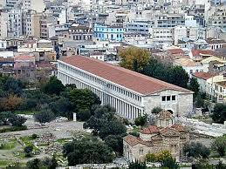

Stoa of Attalos II (Athens)

* + Hellenistic period
  + colonnades of the stoa
  + A gift from a Persian king
  + First mall
  + Doric columns in outer colonnade
  + Ionic columns in inner colonnade
  + 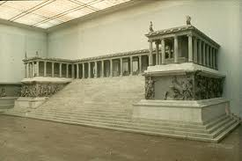

Temple of Zeus (Pergamon) c. 175 BCE

* + Attalos I and the Gauls, Gigantomachy
  + high relief
  + violent movement
  + Dramatic
  + High-relief
  + Built to proclaim victory over barbarians

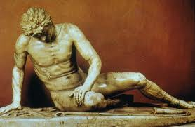

Epigonos. Dying Gaul c. 230-220 BCE

* + theatrical, moving, and noble representations of an enemy
  + pathos
  + tubicen with a torque-rope necklace around neck signifies he was a Gaul, or a barbarian
  + Doesn't proclaim strength but shows weakness of enemy
  + Roman copy of a Greek bronze original
  + 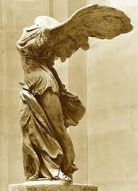

Nike of Samothrace c. 190 BCE

* + suggestion of movement
  + effect of statuary amplified by its setting
  + Created to celebrate a naval victory
  + Part of a fountain
  + Marble
  + 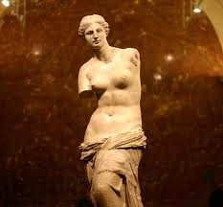

Alexandros of Antioch-on-the-Meander. Venus de Milo c. 150-125 BCE

* + teasing the spectator
  + Erotic
  + May have possibly been holding a shield in which to admire herself
  + Praxtilean curve
  + Six feet, eight inches
  + Greek original
  + 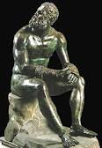

Seated Boxer 100-50 BCE

* + using art to appeal to the emotions rather than to the intellect
  + addressing the subject of defeat
  + Bronze
  + Texture of skin on bronze shows scars, cuts, bruises, etc., to show pain and suffering

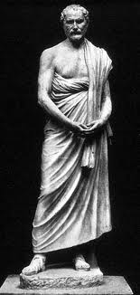

Polyeuktos. Demosthenes c. 280 BCE

* + using art to capture a likeness and personality
  + realistic depiction vs. an idealized one
  + Worry and pain
  + Famous public speaker
  + Has clothing
  + 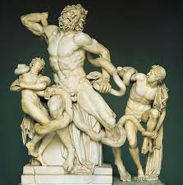

Athanadoros, Hagesandros, and Polydoros of Rhodes. Laocoon and his Sons, early 1st century AD

* + Dramatic
  + Original marble
  + Excavated in Rome
  + Muscular
  + Laocoon-priest
  + Art as a theatrical device
  + Serpents were sent by the gods to devour Laocoon and his sons
  + Laocoon told Trojans not to allow the Trojan Horse into Troy
  + Michelangelo headed excavation team
  + Supposedly inspiration for Sistine Chapel

Main Idea

Aegean Art: three different cultures; Cycladic, Minoans, and Myceneans. Minoans were very peaceful. Leader was King Minos. Created buon fresco. Temple of Knosses. Myceneans were a very warring nation. Used corbeling in creating archways and walls.

Greek Art: birth of humanism. Pursuit of the ideal canon because man was the measure of all things. Geometric used simple shapes. Archaic used lots of stylization, no emotion, archaic smile, and use of bases. Classical started when Athens defeated Persians. First use of contraposso, which created realistic and lifelike movement. Sculptures were also very calm and serene. Late classical was the bridge between classical and Hellenistic, which was the time of Alexander the Great. Hellenistic combined cultures of the Persians with Greek as well. Emotional and lots of muscular definition.