Campbell's Biology, 9e (Reece et al.)
Chapter 2 The Chemical Context of Life

This chapter presents basic chemical principles for understanding the chemical context of living organisms, from atomic structure to the nature of chemical bonds and an introduction to chemical equilibrium. These questions focus on elements most important to life or the study of life, including the elements that comprise organic molecules and important trace elements. Some isotopes are important in geologic dating and in biological tracer studies. How elements participate in forming different types of chemical bonds is essential to mastering subsequent topics on the behavior and properties of biological molecules, structures, and energy metabolism.

Multiple-Choice Questions

1) About 25 of the 92 natural elements are known to be essential to life. Which four of these 25 elements make up approximately 96% of living matter?
A) carbon, sodium, hydrogen, nitrogen
B) carbon, oxygen, phosphorus, hydrogen
C) oxygen, hydrogen, calcium, nitrogen
D) carbon, hydrogen, nitrogen, oxygen
E) carbon, oxygen, nitrogen, calcium
Answer: D
Topic: Concept 2.1
Skill: Knowledge/Comprehension

2) Trace elements are those required by an organism in only minute quantities. Which of the following is a trace element that is required by humans and other vertebrates, but not by other organisms such as bacteria or plants?
A) nitrogen
B) calcium
C) iodine
D) sodium
E) phosphorus
Answer: C
Topic: Concept 2.1
Skill: Knowledge/Comprehension

3) Which of the following statements is false?
A) Carbon, hydrogen, oxygen, and nitrogen are the most abundant elements of living matter.
B) Some trace elements are very abundant on Earth.
C) Virtually all organisms require the same elements in the same quantities.
D) Iron is an example of an element needed by all organisms.
E) Other than some trace elements, animals are mostly made up of the same elements as plants, in similar proportions.
Answer: C
Topic: Concept 2.1
Skill: Application/Analysis
4) What factors are most important in determining which elements are most common in living matter?
A) the relative abundances of the elements in Earth's crust and atmosphere
B) the emergent properties of the simple compounds made from these elements
C) the reactivity of the elements with water
D) the chemical stability of the elements
E) both the relative abundances of the elements and the emergent properties of the compounds made from these elements
Answer: E
Topic: Concept 2.1
Skill: Synthesis/Evaluation

5) Why is each element unique and different from other elements in chemical properties?
A) Each element has a unique atomic mass.
B) Each element has a unique atomic weight.
C) Each element has a unique number of protons in its nucleus.
D) Each element has a unique number of neutrons in its nucleus.
E) Each element has different radioactive properties.
Answer: C
Topic: Concept 2.2
Skill: Knowledge/Comprehension

6) Knowing just the atomic mass of an element allows inferences about which of the following?
A) the chemical properties of the element
B) the number of protons in the element
C) the number of neutrons in the element
D) the number of protons plus neutrons in the element
E) both the number of protons and the chemical properties of the element
Answer: D
Topic: Concept 2.2
Skill: Application/Analysis

7) In what way are elements in the same column of the periodic table the same?
A) They have the same number of protons.
B) They have the same number of neutrons.
C) They have the same number of electrons.
D) They have the same number of electrons in their valence shell.
E) They have the same number of electron shells.
Answer: D
Topic: Concept 2.2
Skill: Knowledge/Comprehension
8) Oxygen has an atomic number of 8 and a mass number of 16. Thus, what is the atomic mass of an oxygen atom?
A) exactly 8 grams
B) exactly 8 daltons
C) approximately 16 grams
D) approximately 16 daltons
E) 24 amu (atomic mass units)
Answer: D
Topic: Concept 2.2
Skill: Knowledge/Comprehension

9) The nucleus of a nitrogen atom contains 7 neutrons and 7 protons. Which of the following is a correct statement concerning nitrogen?
A) The nitrogen atom has a mass number of approximately 7 daltons and an atomic mass of 14.
B) The nitrogen atom has a mass number of approximately 14 daltons and an atomic mass of 7.
C) The nitrogen atom has a mass number of 14 and an atomic mass of 7 grams.
D) The nitrogen atom has a mass number of 7 and an atomic number of 14.
E) The nitrogen atom has a mass number of 14 and an atomic mass of approximately 14 daltons.
Answer: E
Topic: Concept 2.2
Skill: Knowledge/Comprehension

10) Molybdenum has an atomic number of 42. Several common isotopes exist, with mass numbers of 92, 94, 95, 96, 97, 98, and 100. Therefore, which of the following can be true?
A) Molybdenum atoms can have between 50 and 58 neutrons.
B) The isotopes of molybdenum have different electron configurations.
C) The isotopes of molybdenum can have between 50 and 58 protons.
D) The isotopes of molybdenum have between 50 and 58 neutrons and have different electron configurations.
E) The isotopes of molybdenum have between 50 and 58 protons and have different electron configurations.
Answer: A
Topic: Concept 2.2
Skill: Knowledge/Comprehension
11) Carbon-12 is the most common isotope of carbon, and has an atomic mass of 12 daltons. A mole of carbon in naturally occurring coal, however, weighs slightly more than 12 grams. Why?
A) The atomic mass does not include the mass of electrons.
B) Some carbon atoms in nature have an extra proton.
C) Some carbon atoms in nature have more neutrons.
D) Some carbon atoms in nature have a different valence electron distribution.
E) Some carbon atoms in nature have undergone radioactive decay.
Answer: C
Topic: Concept 2.2
Skill: Application/Analysis

12) Which of the following best describes the relationship between the atoms described below?

Atom 1 Atom 2
H H

A) They are isomers.
B) They are polymers.
C) They are isotopes.
D) They contain 1 and 3 protons, respectively.
E) They each contain 1 neutron.
Answer: C
Topic: Concept 2.2
Skill: Knowledge/Comprehension

13) The precise weight of a mole of some pure elements like silicon (Si) can vary slightly from the standard atomic mass, or even from sample to sample. Why?
A) The element may undergo radioactive decay.
B) The element may react with itself and gain or lose subatomic particles.
C) The atoms of the element form chemical bonds with each other, and that changes the weight of the element.
D) The element may have multiple stable isotopes, and the isotopic composition may vary from sample to sample.
E) The amount of energy absorbed by the element affects the mass of its electrons, and thus the atomic mass can vary slightly.
Answer: D
Topic: Concept 2.2
Skill: Application/Analysis
14) One difference between carbon-12 () is that carbon-14 () has
A) two more protons than carbon-12.
B) two more electrons than carbon-12.
C) two more neutrons than carbon-12.
D) two more protons and two more neutrons than carbon-12.
E) two more electrons and two more neutrons than carbon-12.
Answer: C
Topic: Concept 2.2
Skill: Knowledge/Comprehension

15) An atom has 6 electrons in its outer shell. How many unpaired electrons does it have?
A) 0
B) 2
C) 4
D) 6
E) 2 or 4
Answer: B
Topic: Concept 2.2
Skill: Knowledge/Comprehension

16) The atomic number of nitrogen is 7. Nitrogen-15 is heavier than nitrogen-14 because the atomic nucleus of nitrogen-15 contains how many neutrons?
A) 6
B) 7
C) 8
D) 12
E) 14
Answer: C
Topic: Concept 2.2
Skill: Knowledge/Comprehension

17) Electrons exist only at fixed levels of potential energy. However, if an atom absorbs sufficient energy, a possible result is that
A) an electron may move to an electron shell farther away from the nucleus.
B) an electron may move to an electron shell closer to the nucleus.
C) the atom may become a radioactive isotope.
D) the atom would become a positively charged ion, or cation, and become a radioactive isotope.
E) the atom would become a negatively charged ion, or anion.
Answer: A
Topic: Concept 2.2
Skill: Knowledge/Comprehension
18) The atomic number of neon is 10. Therefore, which of the following is most correct about an atom of neon?
A) It has 8 electrons in its outer electron shell.
B) It is inert.
C) It has an atomic mass of 10 daltons.
D) It has 8 electrons in its outer electron shell and it is inert.
E) It has 8 electrons in its outer electron shell, it is inert, and it has an atomic mass of 10 daltons.
Answer: D
Topic: Concept 2.2
Skill: Knowledge/Comprehension

19) From its atomic number of 15, it is possible to predict that the phosphorus atom has
A) 15 neutrons.
B) 15 protons.
C) 15 electrons.
D) 8 electrons in its outermost electron shell.
E) 15 protons and 15 electrons.
Answer: E
Topic: Concept 2.2
Skill: Knowledge/Comprehension

20) Atoms whose outer electron shells contain 8 electrons tend to
A) form ions in aqueous solutions.
B) form hydrogen bonds in aqueous solutions.
C) be stable and chemically nonreactive, or inert.
D) be gaseous at room temperature.
E) be both chemically inert and gaseous at room temperature.
Answer: E
Topic: Concept 2.2
Skill: Knowledge/Comprehension

21) The atomic number of each atom is given to the left of each of the elements below. Which of the atoms has the same valence as carbon ()?
A) 7N nitrogen
B) 9F flourine
C) 10Ne neon
D) 12Mg magnesium
E) 14Si silicon
Answer: E
Topic: Concept 2.2
Skill: Application/Analysis
22) Two atoms appear to have the same mass number. These atoms
A) must have the same atomic number.
B) must have the same number of electrons.
C) must have the same chemical properties.
D) must have the same number of protons + neutrons.
E) must have the same atomic number, the same number of protons + neutrons, the same number of electrons, and the same chemical properties.
Answer: D
Topic: Concept 2.2
Skill: Synthesis/Evaluation

23) Fluorine has an atomic number of 9 and a mass number of 19. How many electrons are needed to complete the valence shell of a fluorine atom?
A) 1
B) 3
C) 0
D) 7
E) 9
Answer: A
Topic: Concept 2.2
Skill: Knowledge/Comprehension

24) What is the maximum number of electrons in a single 2 p orbital of an atom?
A) 1
B) 2
C) 3
D) 4
E) 5
Answer: B
Topic: Concept 2.2
Skill: Knowledge/Comprehension
25) The organic molecules in living organisms have a measurably lower ratio of carbon-13/carbon-12, two stable isotopes of carbon that comprise approximately 1.1% and 98.9% of atmospheric carbon, respectively. What is a reasonable explanation for this phenomenon?
A) Photosynthesis preferentially uses carbon dioxide molecules with carbon-12, and the lower carbon-13/carbon-12 ratio propagates through the food chain.
B) Carbon dioxide molecules with carbon-13 stay in the upper atmosphere and are less available to terrestrial plants and algae.
C) Carbon-13 has a different valence electron configuration and is therefore less chemically reactive than carbon-12.
D) Oxygen atoms preferentially react with carbon-13, thereby enriching the atmosphere with carbon dioxide molecules containing carbon-13 atoms.
E) Carbon dioxide molecules containing carbon-13 are heavier and sink into the ocean depths, making them less available to living organisms.
Answer: A
Topic: Concepts 2.2, 2.4
Skill: Synthesis/Evaluation

26) Phosphorus-32, a radioactive isotope of phosphorus-31 (atomic number 15), undergoes a form of radioactive decay whereby a neutron turns into a proton and emits radiation in the form of an electron. What is the product of such radioactive decay of phosphorus-32?
A) phosphorus-31
B) a positively charged phosphorus-31 ion
C) a negatively charged phosphorus-32 ion
D) sulfur-32 (atomic number 16)
E) the conversion of the phosphorus-32 atom into pure energy
Answer: D
Topic: Concept 2.2
Skill: Application/Analysis

27) An atom with atomic number 12 would have what type of chemical behavior in bonding with other elements?
A) It would form ions with a +1 charge.
B) It would form ions with a +2 charge.
C) It would form ions with a -1 charge.
D) It would form ions with a -2 charge.
E) It would form two covalent bonds with other atoms.
Answer: B
Topic: Concept 2.3
Skill: Application/Analysis
28) If a salamander relied on hydrogen bonds to cling to surfaces, what type of surface would cause the most problems for this animal?
A) a surface coated with a thin film of water
B) a surface made with carbon and hydrogen atoms covalently bonded together
C) a surface made with carbon, hydrogen, and oxygen atoms covalently bonded together
D) a surface made with carbon, hydrogen, nitrogen, and oxygen atoms covalently bonded together
E) a surface made with silicon and oxygen atoms covalently bonded together
Answer: B
Topic: Concept 2.3
Skill: Synthesis/Evaluation

29) A covalent chemical bond is one in which
A) electrons are removed from one atom and transferred to another atom so that the two atoms become oppositely charged.
B) protons and neutrons are shared by two atoms so as to satisfy the requirements of both atoms.
C) outer-shell electrons of two atoms are shared so as to satisfactorily fill the outer electron shells of both atoms.
D) outer-shell electrons of one atom are transferred to fill the inner electron shell of another atom.
E) an electron occupies a hybrid orbital located between the nuclei of two atoms.
Answer: C
Topic: Concept 2.3
Skill: Knowledge/Comprehension

30) If an atom of sulfur (atomic number 16) were allowed to react with atoms of hydrogen (atomic number 1), which of the molecules below would be formed?

A) SH

B) HSH

C) HSH
|
H
D)
H
|
HSH
|
H

E) HSH

Answer: B
Topic: Concept 2.3
Skill: Application/Analysis
31) What is the maximum number of covalent bonds an element with atomic number 8 can make with hydrogen?
A) 1
B) 2
C) 3
D) 4
E) 6
Answer: B
Topic: Concept 2.3
Skill: Knowledge/Comprehension

32) Nitrogen (N) is much more electronegative than hydrogen (H). Which of the following statements is correct about the atoms in ammonia (NH3)?
A) Each hydrogen atom has a partial positive charge; the nitrogen atom has a partial negative charge.
B) The nitrogen atom has a strong positive charge; each hydrogen atom has a strong positive charge.
C) Each hydrogen atom has a slight negative charge; the nitrogen atom has a strong positive charge.
D) The nitrogen atom has a slight positive charge; each hydrogen atom has a slight negative charge.
E) There are covalent bonds between the hydrogen atoms and polar bonds between each hydrogen atom and the nitrogen atom.
Answer: A
Topic: Concept 2.3
Skill: Knowledge/Comprehension

33) When two atoms are equally electronegative, they will interact to form
A) hydrogen bonds.
B) van der Waals interactions.
C) polar covalent bonds.
D) nonpolar covalent bonds.
E) ionic bonds.
Answer: D
Topic: Concept 2.3
Skill: Knowledge/Comprehension

34) What results from an unequal sharing of electrons between atoms?
A) a nonpolar covalent bond
B) a polar covalent bond
C) an ionic bond
D) a hydrogen bond
E) a hydrophobic interaction
Answer: B
Topic: Concept 2.3
Skill: Knowledge/Comprehension
35) A covalent bond is likely to be polar when
A) one of the atoms sharing electrons is much more electronegative than the other atom.
B) the two atoms sharing electrons are equally electronegative.
C) oxygen is one of the two atoms sharing electrons.
D) one of the atoms has absorbed more energy than the other atom.
E) the two atoms sharing electrons are different elements.
Answer: A
Topic: Concept 2.3
Skill: Knowledge/Comprehension

36) Which of the following molecules contains the most polar covalent bond?
A) H2
B) O2
C) CO2
D) H2O
E) CH4
Answer: D
Topic: Concept 2.3
Skill: Knowledge/Comprehension

37) In comparing covalent bonds and ionic bonds, which of the following would you expect?
A) An atom can form covalent bonds with multiple partner atoms, but only a single ionic bond with a single partner atom.
B) Covalent bonds and ionic bonds occupy opposite ends of a continuous spectrum, from nearly equal to completely unequal sharing of electrons.
C) Both involve electrical attraction between the electrons of one atom and the nucleus of the other atom.
D) Ionic interactions remain when covalent bonds are broken in water. Ionic bonds are much stronger than covalent bonds.
Answer: B
Topic: Concept 2.3
Skill: Synthesis/Evaluation
38) What is the difference between covalent bonds and ionic bonds?
A) Covalent bonds are formed between atoms to form molecules; ionic bonds are formed between atoms to form compounds.
B) Covalent bonds involve the sharing of pairs of electrons between atoms; ionic bonds involve the sharing of single electrons between atoms.
C) Covalent bonds involve the sharing of electrons between atoms; ionic bonds involve the electrical attraction between atoms.
D) Covalent bonds involve the sharing of electrons between atoms; ionic bonds involve the sharing of protons between atoms.
E) Covalent bonds involve the transfer of electrons between atoms; ionic bonds involve the sharing of electrons between atoms.
Answer: C
Topic: Concept 2.3
Skill: Knowledge/Comprehension

39) In ammonium chloride salt (NH4Cl) the anion is a single chloride ion, Cl. What is the cation of NH4Cl?
A) N, with a charge of +1
B) NH, with a charge of +1
C) H3, with a charge of +1
D) NH4, with a charge of +1
E) NH4, with a charge of +4
Answer: D
Topic: Concept 2.3
Skill: Knowledge/Comprehension

40) The atomic number of chlorine is 17. The atomic number of magnesium is 12. What is the formula for magnesium chloride?
A) MgCl
B) MgCl2
C) Mg2Cl
D) Mg2Cl2
E) MgCl3
Answer: B
Topic: Concept 2.3
Skill: Application/Analysis
41) How many electron pairs are shared between carbon atoms in a molecule that has the formula C2H4?
A) 0
B) 1
C) 2
D) 3
E) 4
Answer: C
Topic: Concept 2.3
Skill: Application/Analysis

42) Which bond or interaction would be difficult to disrupt when compounds are put into water?
A) covalent bond
B) hydrogen bond
C) van der Waals interaction
D) ionic bond
E) either covalent bonds or ionic bonds
Answer: A
Topic: Concept 2.3
Skill: Application/Analysis

43) Which of the following explains most specifically the attraction of water molecules to one another?
A) nonpolar covalent bond
B) polar covalent bond
C) ionic bond
D) hydrogen bond
E) hydrophobic interaction
Answer: D
Topic: Concept 2.3
Skill: Knowledge/Comprehension

44) Van der Waals interactions result when
A) hybrid orbitals overlap.
B) electrons are not symmetrically distributed in a molecule.
C) molecules held by ionic bonds react with water.
D) two polar covalent bonds react.
E) a hydrogen atom loses an electron.
Answer: B
Topic: Concept 2.3
Skill: Knowledge/Comprehension
45) What bonding or interaction is most likely to occur among a broad array of molecules of various types (polar, nonpolar, hydrophilic, hydrophobic)?
A) covalent bonding
B) polar covalent bonding
C) ionic bonding
D) hydrogen bonding
E) van der Waals interactions
Answer: E
Topic: Concept 2.3
Skill: Synthesis/Evaluation

46) Which of the following is not considered to be a weak molecular interaction?
A) a covalent bond
B) a van der Waals interaction
C) an ionic bond in the presence of water
D) a hydrogen bond
E) both a hydrogen bond and a covalent bond
Answer: A
Topic: Concept 2.3
Skill: Knowledge/Comprehension

47) Which of the following would be regarded as compounds?
A) H2O, O2, and CH4
B) H2O and O2
C) O2 and CH4
D) CH4 and O2, but not H2O
E) H2O and CH4, but not O2
Answer: E
Topic: Concept 2.3
Skill: Application/Analysis

48) What is the maximum number of hydrogen atoms that can be covalently bonded in a molecule containing two carbon atoms?
A) 2
B) 3
C) 4
D) 6
E) 8
Answer: D
Topic: Concept 2.3
Skill: Application/Analysis
49) Which of the following is true for this reaction?

3 H2 + N2 ↔ 2 NH3

A) The reaction is nonreversible.
B) Hydrogen and nitrogen are the reactants of the reverse reaction.
C) Hydrogen and nitrogen are the products of the forward reaction.
D) Ammonia is being formed and decomposed.
E) Hydrogen and nitrogen are being decomposed.
Answer: D
Topic: Concept 2.4
Skill: Knowledge/Comprehension

50) Which of the following correctly describes chemical equilibrium?
A) Forward and reverse reactions continue with no effect on the concentrations of the reactants and products.
B) Concentrations of products are higher than the concentrations of the reactants.
C) Forward and reverse reactions have stopped so that the concentration of the reactants equals the concentration of the products.
D) Reactions stop only when all reactants have been converted to products.
E) There are equal concentrations of reactants and products, and the reactions have stopped.
Answer: A
Topic: Concept 2.4
Skill: Knowledge/Comprehension

51) Which of the following correctly describes any reaction that has reached chemical equilibrium?
A) The concentration of the reactants equals the concentration of the products.
B) The rate of the forward reaction is equal to the rate of the reverse reaction.
C) All of the reactants have been converted to the products of the reaction.
D) All of the products have been converted to the reactants of the reaction.
E) Both the forward and the reverse reactions have stopped with no net effect on the concentration of the reactants and the products.
Answer: B
Topic: Concept 2.4
Skill: Knowledge/Comprehension
52) Which of these systems is least likely to be at chemical equilibrium?
A) a test tube of living cells
B) a test tube of organic molecules, kept in the freezer
C) a test tube of dry organic molecules, kept at room temperature
D) a test tube of organic molecules dissolved in water, kept at room temperature
E) a test tube of dead cells in water, kept at room temperature
Answer: A
Topic: Concept 2.4
Skill: Synthesis/Evaluation

Art Questions

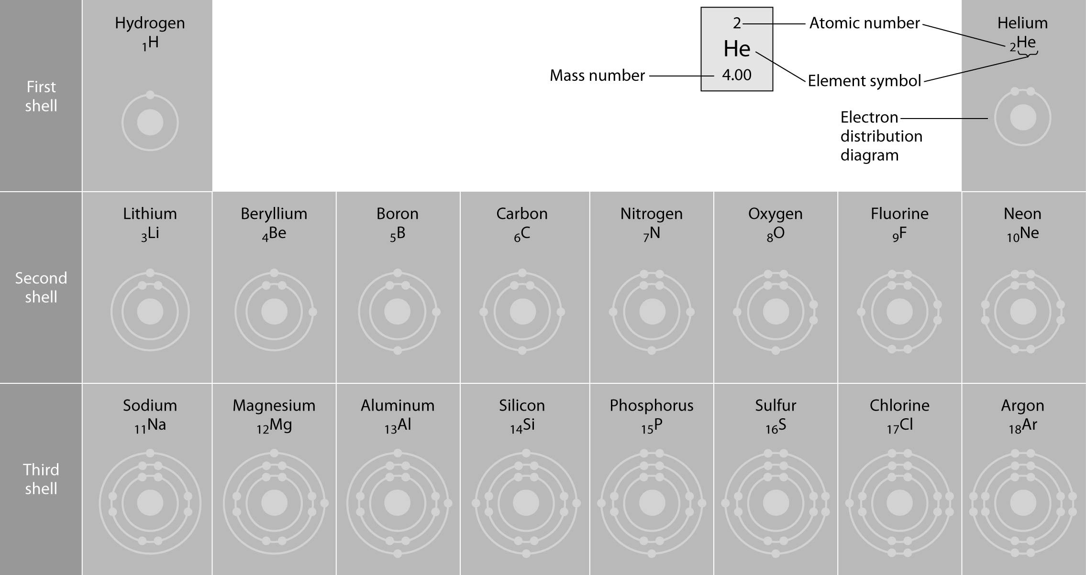

53) Refer to the figure above (first three rows of the periodic table). If life arose on a planet where carbon is absent, which element might fill the role of carbon?
A) boron
B) silicon
C) nitrogen
D) aluminum
E) phosphorus
Answer: B
Topic: Concept 2.2
Skill: Synthesis/Evaluation
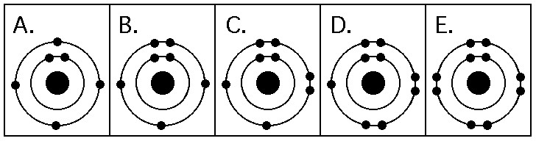

54) Which drawing in the figure above depicts the electron configuration of an element with chemical properties most similar to Helium (2He)?
A) A
B) B
C) C
D) D
E) E
Answer: E
Topic: Concept 2.2
Skill: Application/Analysis

55) Which drawing in the figure above depicts the electron configuration of an atom that can form covalent bonds with two hydrogen atoms?
A) A
B) B
C) C
D) D
E) E
Answer: C
Topic: Concept 2.3
Skill: Application/Analysis

56) Which drawing in the figure above depicts the electron configuration of an atom capable of forming three covalent bonds with other atoms?
A) A
B) B
C) C
D) D
E) E
Answer: B
Topic: Concept 2.3
Skill: Application/Analysis
57) Which drawing in the figure above is of the electron configuration of a sodium 11Na+ ion?
A) A
B) B
C) C
D) D
E) E
Answer: E
Topic: Concept 2.3
Skill: Application/Analysis

58) Which drawing in the figure above depicts the most electronegative atom?
A) A
B) B
C) C
D) D
E) E
Answer: D
Topic: Concept 2.3
Skill: Knowledge/Comprehension

59) Which drawing in the figure above depicts an atom with a valence of 3?
A) A
B) B
C) C
D) D
E) E
Answer: B
Topic: Concept 2.2
Skill: Knowledge/Comprehension

60) Which drawing in the figure above depicts an atom with a valence of 2?
A) A
B) B
C) C
D) D
E) E
Answer: C
Topic: Concept 2.2
Skill: Knowledge/Comprehension
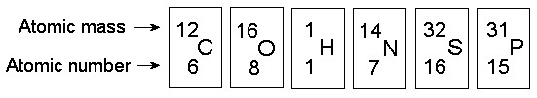

61) In the figure above, how many electrons does nitrogen have in its valence shell?
A) 2
B) 5
C) 7
D) 8
E) 14
Answer: B
Topic: Concept 2.2
Skill: Knowledge/Comprehension

62) In the figure above, how many unpaired electrons does phosphorus have in its valence shell?
A) 15
B) 2
C) 3
D) 7
E) 5
Answer: C
Topic: Concept 2.2
Skill: Knowledge/Comprehension

63) How many neutrons are present in the nucleus of a phosphorus-32 (32P) atom (see the figure above)?
A) 5
B) 15
C) 16
D) 17
E) 32
Answer: D
Topic: Concept 2.2
Skill: Knowledge/Comprehension

64) How many electrons does an atom of sulfur have in its valence shell (see the figure above)?
A) 4
B) 6
C) 8
D) 16
E) 32
Answer: B
Topic: Concept 2.2
Skill: Knowledge/Comprehension
65) Based on electron configuration, which of these elements in the figure above would exhibit a chemical behavior most like that of oxygen?
A) carbon
B) hydrogen
C) nitrogen
D) sulfur
E) phosphorus
Answer: D
Topic: Concept 2.2
Skill: Application/Analysis

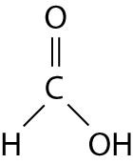

66) The illustration above shows a representation of formic acid. A formic acid molecule
A) will form hydrogen bonds with water molecules.
B) has a tetrahedral configuration of hybrid electron orbitals for the carbon atom.
C) consists of largely nonpolar covalent bonds.
D) is held together by hydrogen bonds.
E) has a tetrahedral shape and will form hydrogen bonds with water molecules.
Answer: A
Topic: Concept 2.3
Skill: Synthesis/Evaluation

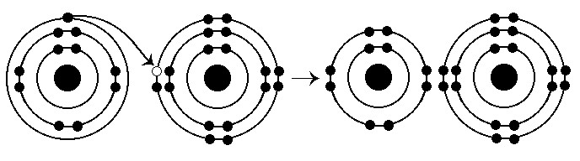

67) What results from the chemical reaction illustrated above?
A) a cation with a net charge of +1
B) a cation with a net charge of -1
C) an anion with a net charge of +1
D) an anion with a net charge of -1
E) a cation with a net charge of +1 and an anion with a net charge of -1
Answer: E
Topic: Concept 2.3
Skill: Knowledge/Comprehension
68) What is the atomic number of the cation formed in the reaction illustrated above?
A) 1
B) 8
C) 10
D) 11
E) 16
Answer: D
Topic: Concept 2.3
Skill: Application/Analysis

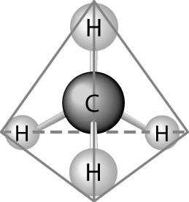

69) What causes the shape of the molecule shown above?
A) the configuration of the 2 p orbitals in the carbon atom
B) the configuration of the 1 s orbital in the carbon atom
C) the configuration of the sp hybrid orbitals of the electrons shared between the carbon and hydrogen atoms
D) the packing of the carbon and hydrogen atoms in a crystal lattice
E) hydrogen bonding configurations between the carbon and hydrogen atoms
Answer: C
Topic: Concept 2.3
Skill: Knowledge/Comprehension

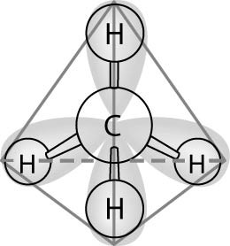

70) In the methane molecule shown in the figure above, bonds have formed that include both the s orbital valence electrons of the hydrogen atoms and the p orbital valence electrons of the carbon. The electron orbitals in these bonds are said to be
A) double orbitals.
B) tetrahedral orbitals.
C) complex orbitals.
D) hybrid orbitals.
E) polar orbitals.
Answer: D
Topic: Concept 2.3
Skill: Knowledge/Comprehension
71) Which one of the atoms shown would be most likely to form a cation with a charge of +1?
A)
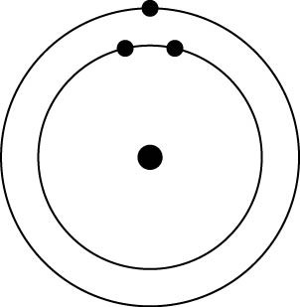
B)
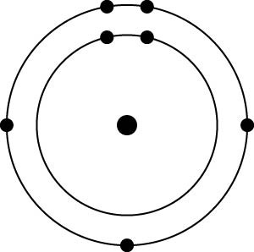
C)
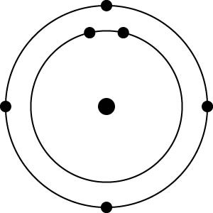
D)
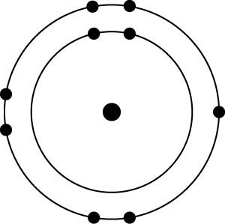
E)
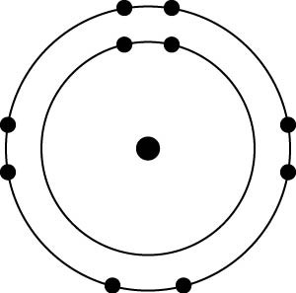
Answer: A
Topic: Concept 2.3
Skill: Application/Analysis
72) Which one of the atoms shown would be most likely to form an anion with a charge of -1?
A)
B)
C)
D)
E)
Answer: D
Topic: Concept 2.3
Skill: Application/Analysis

73) Which of the following pairs of atoms would be most likely to form a polar covalent bond?
A)
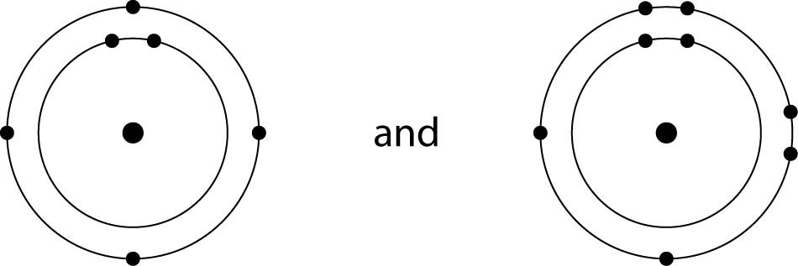
B)
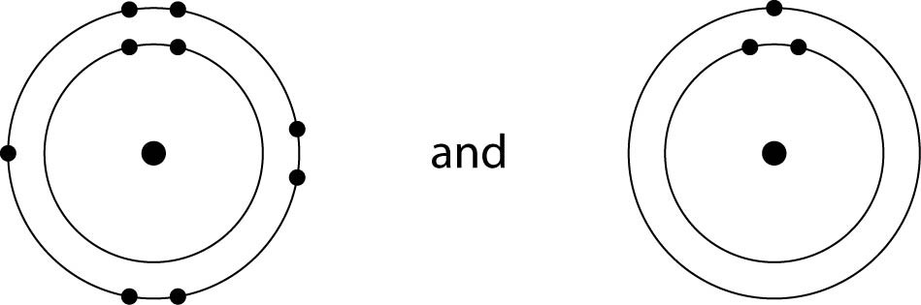
C)
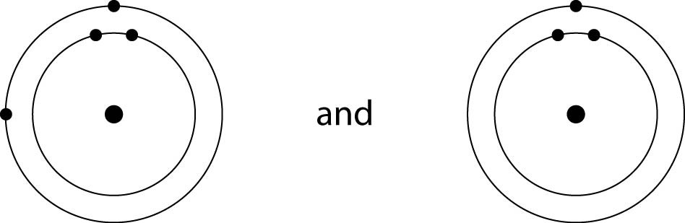
D)
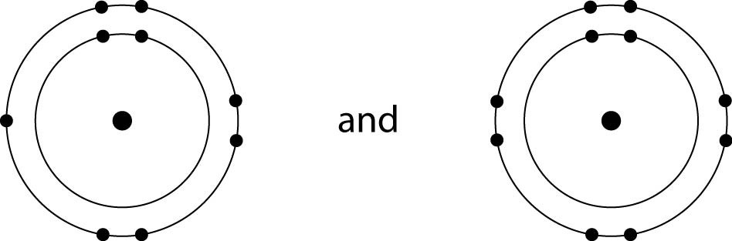
E)
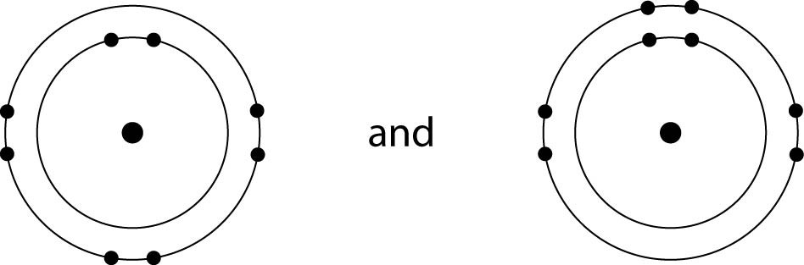
Answer: A
Topic: Concept 2.3
Skill: Application/Analysis

74) Which of the following pairs of atoms would be most likely to form an ionic bond?
A)
B)
C)
D)
E)
Answer: B
Topic: Concept 2.3
Skill: Application/Analysis

Scenario Question

75) A group of molecular biologists is trying to synthesize a new artificial compound to mimic the effects of a known hormone that influences sexual behavior. They have turned to you for advice. Which of the following compounds is most likely to mimic the effects of the hormone?
A) a compound with the same number of carbon atoms as the hormone
B) a compound with the same molecular mass (measured in daltons) as the hormone
C) a compound with the same three-dimensional shape as part of the hormone
D) a compound with the same number of orbital electrons as the hormone
E) a compound with the same number of hydrogen and nitrogen atoms as the hormone
Answer: C
Topic: Concept 2.4
Skill: Application/Analysis

End-of-Chapter Questions

The following questions are from the end-of-chapter “Test Your Understanding” section in Chapter 2 of the textbook.

76) In the term trace element, the modifier trace means that
A) the element is required in very small amounts.
B) the element can be used as a label to trace atoms through an organism's metabolism.
C) the element is very rare on Earth.
D) the element enhances health but is not essential for the organism's long-term survival.
E) the element passes rapidly through the organism.
Answer: A
Topic: End-of-Chapter Questions
Skill: Knowledge/Comprehension
77) Compared with 31P, the radioactive isotope 32P has
A) a different atomic number.
B) a different charge.
C) one more proton.
D) one more electron.
E) one more neutron.
Answer: E
Topic: End-of-Chapter Questions
Skill: Knowledge/Comprehension

78) The reactivity of an atom arises from
A) the average distance of the outermost electron shell from the nucleus.
B) the existence of unpaired electrons in the valence shell.
C) the sum of the potential energies of all the electron shells.
D) the potential energy of the valence shell.
E) the energy difference between the s and p orbitals.
Answer: B
Topic: End-of-Chapter Questions
Skill: Knowledge/Comprehension

79) Which statement is true of all atoms that are anions?
A) The atom has more electrons than protons.
B) The atom has more protons than electrons.
C) The atom has fewer protons than does a neutral atom of the same element.
D) The atom has more neutrons than protons.
E) The net charge is 1-.
Answer: A
Topic: End-of-Chapter Questions
Skill: Knowledge/Comprehension

80) Which of the following statements correctly describes any chemical reaction that has reached equilibrium?
A) The concentrations of products and reactants are equal.
B) The reaction is now irreversible.
C) Both forward and reverse reactions have halted.
D) The rates of the forward and reverse reactions are equal.
E) No reactants remain.
Answer: D
Topic: End-of-Chapter Questions
Skill: Knowledge/Comprehension
81) We can represent atoms by listing the number of protons, neutrons, and electronsfor example,
2p+; 2n0; 2e- for helium. Which of the following represents the 18O isotope of oxygen?
A) 6p+, 8n0, 6e-
B) 8p+, 10n0, 8e-
C) 9p+, 9n0, 9e-
D) 7p+, 2n0, 9e-
E) 10p+, 8n0, 9e-
Answer: B
Topic: End-of-Chapter Questions
Skill: Application/Analysis

82) The atomic number of sulfur is 16. Sulfur combines with hydrogen by covalent bonding to form a compound, hydrogen sulfide. Based on the number of valence electrons in a sulfur atom, predict the molecular formula of the compound:
A) HS
B) HS2
C) H2S
D) H3S2
E) H4S
Answer: C
Topic: End-of-Chapter Questions
Skill: Application/Analysis

83) What coefficients must be placed in the following blanks so that all atoms are accounted for in the products?
C6H12O6 → ____ C2H6O + ____ CO2
A) 1; 2
B) 3; 1
C) 1; 3
D) 1; 1
E) 2; 2
Answer: E
Topic: End-of-Chapter Questions
Skill: Application/Analysis

