1. Microeconomics
Basically, microeconomics is a branch, or division, of economics that studies the behavior of how the modern households and firms make decisions to distribute and allocate their limited resources.

Examples: Two examples are a particular industry or the demand of a single product.

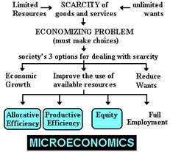

2. Macroeconomics
Macroeconomics is another branch, or division, of economics. It deals with the performance, structure, behavior, and decision-making of the whole economy, instead of a singular thing.

Examples: Two examples are how the Gross Domestic Product is affected by changes in unemployment, and national income.

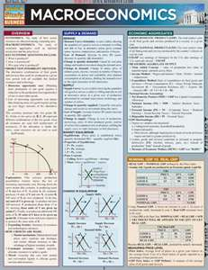

3. Scarcity
Scarcity is the economic problem of having people who have wants and needs, but have a limited amount of resources to do anything about it.

Examples: Goods and services that are known as economic goods are generally very scarce.



4. Land (Natural Resources)
Land comprises all natural resources whose supply is inherently fixed.

Examples: Mineral deposits and geographical locations fall under this category.



5. Labor
It is also known as human resources. It is a term used to describe the individuals who make up the workforce of an organization.

Examples: Employees at a McDonald’s and miners are two examples of human resources.



6. Capital
Physical capital refers to an already-manufactured asset that is applied in production

Examples: Machinery, buildings, or vehicles

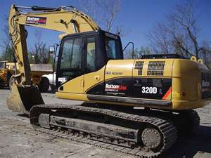

7. Entrepreneur
An entrepreneur is an owner or manager of a business enterprise who makes money through taking risks and having the initiative to accomplish their goals.

Examples: Mark Zuckerberg and Bill Gates



8. Trade-offs
A trade-off is basically a sacrifice one makes to obtain a certain product.

Examples: Trading stocks to obtain cash, and trading an iPod for a PS3.

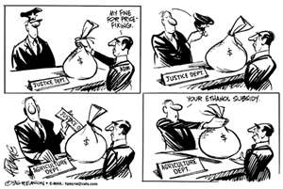

9. Opportunity Cost
The opportunities forgone in the choice of one expenditure over others.

Examples: Giving up a vacation in order to be able to afford a new dishwasher, or giving up your car and taking the bus to save money.

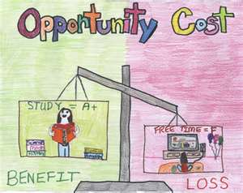

10. Production Possibilities Curve
A graph that compares the production rates of two commodities that use the same fixed total of the factors of production.

Examples of what it shows: All possible combinations of two goods that can be produced simultaneously during a given time period

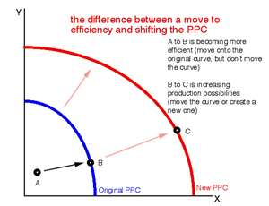

11. Efficiency
It refers to the use of resources so as to maximize the production of certain goods and services.

Examples: Microeconomic reform are policies that aim to reduce economic distortions via deregulation, and increase economic efficiency.

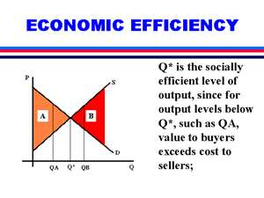

12. Three Key Economic Questions
Because economic resources are limited, every society must answer three economic questions:
a.) What goods and services should be produced? This question asks what should be produced that will bring in the most revenue.
Basic needs, wants, and services should be produced.
Examples are food, luxury item, and shelter.
b.) How should the goods and services be produced? This question asks
In a way that maximizes efficiency and uses the least amount of resources, yet still produces the best work.
Examples of what should be taken into consideration are resources, time, and effort.
c.) Who consumes these goods and services?
Clients and customers consume these items, things that should be taken into consideration are their choices in products, and the prices of the products.

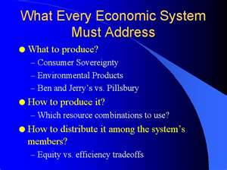

13.Economic system
An economic system is the combination of the various agencies, entities (or even sectors as described by some authors) that provide the economic structure that defines the social community.
Examples: Anarchist, Capitalist, Corporalist

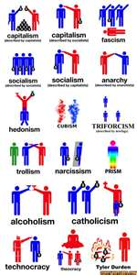

14. Traditional Economy
Economy dominated by methods and techniques that have strong social support even though they may be old-fashioned or out of date

Examples: An agricultural or rural economic system



15. Market Economy
A market economy is an economy in which decisions regarding investment, production and distribution are based on supply and demand and the prices of goods and services are determined in a free price system.

Example: The United States. Canadian, German, and the Netherlands’ economies are all examples of market economies

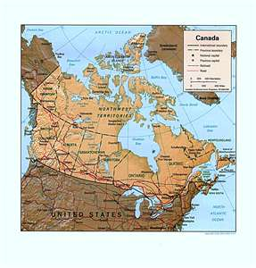

16. Command Economy
A system where the government, rather than the free market, determines what goods should be produced, how much should be produced and the price at which the goods will be offered for sale.

Examples: China, Cuba, North Korea and the former Soviet Union are examples of countries that have command economies.

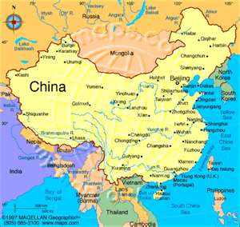

17. Mixed Economy
Mixed economy is an economic system in which both the state and private sector direct the economy, reflecting characteristics of both market economies and planned economies.

Examples: The United States, Canada, Australia, Japan, Germany, the United Kingdom, Italy, etc... are all examples of mixed economies. Examples in the developing world include Mexico, Slovenia, South Africa, etc...

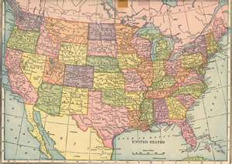

18. The Invisible Hand Theory
Invisible hand of the market is the term economists use to describe the self-regulating nature of the marketplace.

Examples: Garbage collectors in Chicago - they make nearly 6 figures all because they get up in the morning, early, and pick up someone else's refuse. No one wants this job - it stinks, it's dirty, it's messy, it's disgusting. But it's essential to sanitation, and so they are well-paid for it.

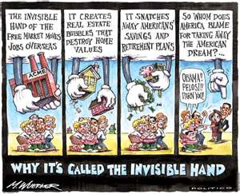
19. Laissez Faire
An economic doctrine that opposes governmental regulation of or interference in commerce beyond the minimum necessary for a free-enterprise system to operate according to its own economic laws. This style describes a leader who leaves his or her colleagues to get on with their work. It can be effective if the leader monitors what is being achieved and communicates this back to his or her team regularly. Most often, laissez-faire leadership works for teams in which the individuals are very experienced and skilled self-starters. Unfortunately, it can also refer to situations where managers are not exerting sufficient control.

Examples: Nixon, Ford, Reagan, Bush, Bush Jr

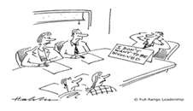

20. Circular Flow Model
In economics, the terms circular flow of income or circular flow refer to a simple economic model which describes the reciprocal circulation of income between producers and consumers. In the circular flow model, the inter-dependent entities of producer and consumer are referred to as "firms" and "households" respectively and provide each other with factors in order to facilitate the flow of income.Firms provide consumers with goods and services in exchange for consumer expenditure and "factors of production" from households. More complete and realistic circular flow models are more complex. They would explicitly include the roles of government and financial markets, along with imports and exports.

