**Unit 4 Test-Political Geography**

1. **Political Geography**: study of political organization of the world; and how the character of those spaces affects social, political, economic, and environmental understandings and practices.
2. **Bi-polar World:** Reference to the Cold War-two great powers in a world face off: United States vs. Soviet Union. Polarized the world into two spheres: capitalism vs. communism. (De Blij p.264 for further reference-discussion of geopolitical world order). Some geographers believe today’s world is bi-polar with the United States and other Western powers pitted against the radical “Islamicization” regimes in the Middle East-(not proven).
3. **Peace of Westphilia**: event in European history that marks the beginning of the modern state. Peace negotiated in 1648 to end the Thirty Years’ War, Europe’s most destructive internal struggle over religion. The treaties contained new language recognizing statehood and nationhood, clearly defined borders, and guarantees of security.
4. **Territorial Integrity**: the right of a state to defend sovereign territory against incursion from other states.
5. **Shatterbelt**: An area full of many different ethnic groups and languages that tend to occur in mountainous regions because the people are separated by barriers. EXAMPLES: Southern Phillipines-clash between Catholics and Muslims.
6. **State**: a politically organized territory that is administered by a sovereign government and is recognized by a significant portion of the international community. A state has a defined territory, a permanent population, a government, and is recognized by other states.
7. **Nation-state**: theoretically, a recognized member of the modern state system possessing formal sovereignty and occupied by a people who see themselves as a single, united nation. Most nations and states aspire to this form, but it is realized almost nowhere. Nonetheless, in common parlance, nation-state is used as a synonym for country or state.

REAL WORLD EXAMPLES: Japan, Bhutan

1. **Nation**: legally, a term encompassing all the citizens of a state. Most definitions now tend to refer to a tightly knit group of people possessing bonds of language, ethnicity, religion, and other shared cultural attributes. Such homogeneity actually prevails within very few states.
2. **Multi-National State**: state with more than one nation within its borders.

REAL WORLD EXAMPLES: Belgium (Flemish North and Walloon South)

1. **Centripetal Forces**: forces that tend to UNIFY a country-such as widespread commitment to a national culture, shared ideological objective, and a common faith. (REMEMBER: Nationalism can be BOTH centripetal and centrifugal).
2. **Unitary State**: a nation-state that has a centralized government and administration that exercises power equally over all parts of the state.

REAL WORLD EXAMPLE: United Kingdom

1. **Organization of State:** 
   1. Unitary-defined above. EXAMPLE: United Kingdom
   2. Federal-central government represents the various entities within a nation-state where they have common interests-defense, foreign affairs, and the like-yet allows these various entities to retain their own identities and to have their own laws, policies, and customs in certain spheres. EXAMPLE: United States
   3. Confederation-states remain sovereign entities with a VERY weak central government. The majority of the power is concentrated in the hands of the states.
2. **Supranational Organization**: a venture involving three or more nation-states involving formal political, economic, and/or cultural cooperation to promote shared objectives.

EXAMPLES: European Union, FIFA, NAFTA,

**Balkanization:** process by which a state breaks down through conflicts among its ethnicities

* threat to peace throughout the world
* lead to WWI
* Yugoslavia
* Afghanistan

**Steps to Marking A Boundary**

* *Define*: define the boundary through a treaty-like legal document, in which actual points in the landscape or points of latitude and longitude are described
* *Delimit*: drawing the boundary on a map
* *Demark*: mark the boundary in the ground with a fence, wall, pillars, or other visible means
* Ex: splitting up of Sudan – South Sudan is now an independent country

**Boundary Disputes**

1. *Definitional*: focus on the legal language of the boundary agreement
   1. The middle line of a river fluctuates
2. *Locational*: definition not in dispute, but interpretation is
   1. Stream that barked the boundary between 2 countries has dried up
3. *Operational*: neighbors differ on the way borders should function
   1. Open or closed border? Limit migration?
   2. Oman & UAE, France & Spain: open border
   3. US & Canada: closed border
4. *Allocational*: conflict over “stuff” – water, oil, gas, etc.
   1. Lake Titicaca: between Bolivia & Peru
   2. Oil reserves under water – exact boundary delimitation is difficult, and can cause disputes

**Frontier:** geographic zone where no state exercises power, provides buffers between states

* the extent of your influence
* don’t exist as much today
* Saudi Arabia & Yemen – last frontier

**Ratzel’s theory of geopolitics:**

* influenced by the writings of Charles Darwin
* “the state resembles a biological organism whose life cycle extends from birth through maturity, and ultimately, decline and death. To prolong its existence, the state requires nourishment, just as an organism needs food. Such nourishment is provided by the acquisition of territories belonging to less powerful competitors and by the people who live there. Territory is the state’s essential, life-giving force.”

**Hungarians in Slovakia:**

* Czechoslovakia: split into Czech Republic and Slovakia
* Slovakia: on the border of Hungary, which means there are many Hungarians living in Slovakia
* Slovakian gypsies – everyone hates
* Identity issues: are these Hungarians in Slovakia Hungarian or Slovakian?
* Border restricts friends/family from seeing one another

**Wallerstein’s world systems theory:**

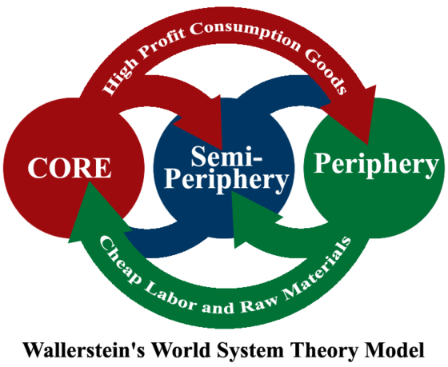

1. The world economy has one market and a global division of labor.
2. Although the world has multiple states, almost everything takes place within the context of the world economy.
3. The world economy has a three-tier structure.
   1. *Core* processes incorporate higher levels of education, higher salaries, and more technology – generate more wealth in the world economy (London)
   2. *Periphery* processes incorporate lower levels of education, lower salaries, and less technology – generate less wealth in the world economy (highlands of Scotland)
   3. *Semiperiphery*: defined as places – places where core and periphery processes are both occurring – places that are exploited by the core but in turn exploit the periphery. Acts as a buffer between the core and periphery, preventing the polarization of the world into 2 extremes (Manchester, Birmingham, Liverpool)

**Samuel Huntingdon’s Thesis:** wrote *The Clash of Civilizations and the Remaking of World Order*

* divisions emerging as a result of recent events could lead to a new bipolar international system pitting the Islamic world against the Judeo-Christian world

**Mercantilism:** “accumulation of wealth through plunder, colonization, and the protection of home industries and foreign markets”

* pursuit of colonization in the name of trade
* wars about trade and access to resources

**Reapportionment:** process by which districts are moved according to population shifts, so that each district encompasses approximately the same number of people

**Gerrymandering:** “redistricting for advantage”

* fixing political boundaries to your own advantage

**Exclave:** bounded (non-island) piece of territory that is part of a state but lies separated from it by territory of another state.

* Alaska – exclave of US
* Belgian exclave in the Netherlands

**Elongated State:** long and narrow shape

* Chile, Gambia, Vietnam
* Problem if the capital isn’t centralized: part of the country can feel neglected, no unity

**Prorupted State:** compact state with a large projecting extension

* often exist to reach a natural resource, such as a river or the ocean
* Southern part of Thailand
* Florida
* Oklahoma
* Russia

**Fragmented:** discontinuous pieces of territory, any state composed of islands

* problematic if some of the islands are remote – difficult to control (Indonesia)
* Alaska

**Compact:** distance from the center of the country to any boundary is about the same, giving it the shape similar to a circle

* Easier to govern if the capital is in the middle
* reduces the risk of outlying areas feeling neglected

**Microstate:** really small countries

* Vatican, Singapore