1. **Intelligence:** A mental quality consisting of the ability to learn from experience, solve problems, and use knowledge to adapt to new situations.
2. **Factor Analysis:** A statistical procedure that identifies clusters of related items (called factors) on a test; used to identify different dimensions of performance that underlie one’s total score.
3. **General Intelligence:** A general intelligence factor that according to Spearman and others underlies specific mental abilities and is therefore measured by every task on an intelligence test.
4. **Savant Syndrome:** A condition in which a person otherwise limited in mental ability has an exceptional skill, such as in computation or drawing.
5. **Emotional Intelligence:** The ability to perceive, understand, manage, and use emotions.
6. **Creativity:** The ability to produce novel and valuable ideas.
7. **Intelligence Test:** A method for assessing an individual’s mental aptitudes and comparing them with those of others, using numerical scores.
8. **Mental Age:** A measure of intelligence test performance devised by Binet; the chronological age that most typically corresponds to a given level of performance. Thus, a child who does as well as the average 8-year-old is said to have a mental age of 8.
9. **Stanford-Binet:** The widely used American revision (by Terman at Stanford University) of Binet’s original intelligence test.
10. **Intelligence Quotient (IQ):** Defined originally as the ratio of mental age to chronological age multiplied by 100 (Thus, IQ = ma/ca x 100). On contemporary intelligence tests, the average performance for a given age is assigned a score of 100.
11. **Aptitude test:** a test designed to predict a person’s future performance; aptitude is the capacity to learn.
12. **Achievement test:** A test designed to assess what a person has learned.
13. **Wechsler Adult Intelligence Scale (WAIS):** the WAIS is the most widely used intelligence test; contains verbal and performance (nonverbal) subtests.
14. **Standardization:** Defining meaningful scores by comparison with the performance of a pretested standardization group.
15. **Normal Curve:** The symmetrical bell-shaped curve that describes the distribution of many physical and psychological attributes. Most scores fall near the average, and fewer and fewer scores lie near the extremes.
16. **Reliability:** The extent to which a test yields consistent results, as assessed by the consistency of scores on two halves of the test, on alternate forms of the test, or on retesting.
17. **Validity:** The extent to which a test measures or predicts what it is supposed to.
18. **Content validity:** The extent to which a test samples the behavior that is of interest (such as a driving test that samples driving tasks).
19. **Criterion:** The behavior (such as future college grades) that a test (such as the SAT) is designed to predict; thus, the measure used in defining whether the test has predictive validity.
20. Predictive validity
21. •success with which a test predicts the behavior that it is designed to predict
22. Mental retardation
23. •Condition of limited mental ability
24. Down syndrome
25. •retardation and associated physical disorders caused by an extra chromosome in the genetic make-up
26. Stereotype threat
27. -the experience of anxiety or concern in a situation where a person has the potential to confirm a negative stereotype about their social group .
29. Chapter 12
31. Motivation
32. •Need or desire that energizes and directs behavior
33. Instinct
34. •complex behavior rigidly patterned throughout a species, unlearned
35. Drive-reduction theory
36. •idea that a physiological need creates an roused tension state that motivates an organism to satisfy the need
37. Homeostasis
38. •tendency to maintain a balanced or constant internal state
39. Incentive
40. •positive/negative environmental stimulus that motivates a behavior
41. Hierarchy of needs
42. •Physiological, safety, belongingness, esteem, self-actualization+
43. Glucose
44. •source of sugar, energy
45. -metabolic intermediate
46. Set point
47. •point @ which individual’s weight thermostat is set.
48. -when body falls below this weight, hunger increases and metabolism decreases
49. Basal metabolic rate
50. •body’s resting rate of energy expenditure
51. Anorexia nervosa
52. •normal weight person diets and becomes underweight
53. Bulimia nervosa
54. •binge-eating then vomiting
55. Sexual response
56. •four stages of sexual responding described by Masters and Johnson- excitement, plateau, orgasm, and resolution
57. Refractory period
58. •time of rest where you can’t have another orgasm
59. Sexual disorder
60. -problem that consistently impairs sex

Estrogen- A sex hormone, secreted in greater amounts by females than males. In non human female mammals, estrogen levels peak during ovulation, promoting sexual receptivity.

Testosterone- The most important male sex hormone. Both males and females have it, but the additional testosterone in males stimulates the growth of the male sex organs in the fetus and the development of the male sex characteristics during puberty.

Industrial-organizational psychology- The application of psychological concepts and methods to optimizing human behavior in workplaces.

* Fastest growing job in psychological field.
* Human factors psychology is one of I/O’s subfields and it has to do with the interaction of how machines and environments can be optimally designed to fit human abilities.

Personnel psychology- A subfield of I/O psychology that focuses on employee recruitment, selection, placement, training, appraisal, and development.

* Personnel Psychologists match people with jobs by identifying and placing well suited candidates.

Organizational psychology- A subfield of I/O psychology that examines organizational influences on worker satisfaction and productivity and facilitated organizational change.

* Organizational psychologists modify jobs and supervision in ways that boost morale and productivity.

Achievement motivation- A desire for significant accomplishment: for mastery of things, people, or ideas; for attaining a high standard.

* for mastery of things, people, or ideas
* for attaining a high standard
* McClelland and Atkinson believed fantasies would reflect achievement concerns

Task leadership- goal-oriented leadership that sets standards, organizes work, and focuses attention on goals

* Being goal oriented task leaders are good at keeping a group centered on its mission.
* Typically they have a directive style

Social leadership- group-oriented leadership that builds teamwork, mediates conflict, and offers support

* Social leaders often have a democratic style: They delegate the authority and welcome the participation of team members.
* Social leadership is good for morale
* Subordinates usually feel more motivated and satisfied when they can participate in decision making.

**Chapter 13**

Emotion- a response of the whole organism

* physiological arousal (heart pounding)
* expressive behaviors (quickened pace)
* conscious experience (thinking)

James-Lange Theory- Experience of emotion is awareness of physiological responses to emotion-arousing stimuli.

Cannon-Bard Theory- Emotion-arousing stimuli simultaneously trigger:

* physiological responses
* subjective experience of emotion

Schacter’s Two Factor Theory- To experience emotion one must:

* be physically aroused
* cognitively label the arousal

Zajonc-

* The brain’s shortcut for emotions

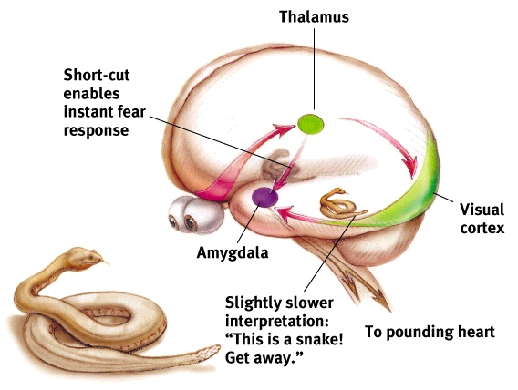

Polygraph- machine commonly used in attempts to detect lies

* measures several of the physiological responses accompanying emotion
* perspiration
* heart rate
* blood pressure
* breathing changes

Catharsis-emotional release

* catharsis hypothesis

1. “releasing” aggressive energy (through action or fantasy) relieves aggressive urges

Feel-good, do-good phenomenon- people’s tendency to be helpful when already in a good mood

Subjective well-being- self-perceived happiness or satisfaction with life

* used along with measures of objective well-being
* physical and economic indicators to evaluate people’s quality of life

Adaptation-level phenomenon-

* tendency to form judgments relative to a “neutral” level

1. brightness of lights
2. volume of sound
3. level of income

* defined by our prior experience

Relative deprivation- perception that one is worse off relative to those with whom one compares oneself