Chapter 2: Neuroscience and Behavior

History of Mind
- Ancient Conceptions About Mind
  - Plato correctly placed mind in the brain. However, his student Aristotle believed that mind was in the heart.
  - Today, all that is psychological is also biological.
- Phrenology
  - 1800, Franz Gall theorized that bumps on the skull represented mental abilities. Wrong, but opened the perspective that different parts of the brain controlled different functions.
- Biological psychologist: studies links btwn biological activity and psychological events.
- Neural Communication
  - Neurons: billions of interconnected nerve cells => body’s info system
  - We are a biopsycholosocial system. cell -> organ -> system -> individual -> family -> ethnic -> community
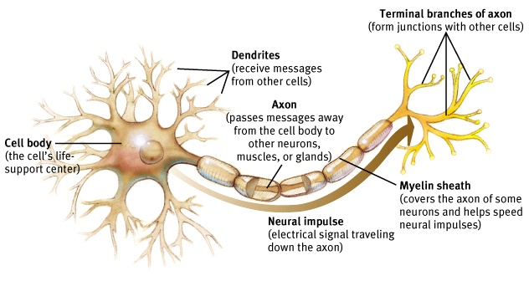
  - Human brains and animal brains process info similarly. This is good for studying without harming humans.
- Neuron
  - Axons speak. Dendrites listen.

- Action Potential: neural impulse. brief electrical charge that travels down axon.
  - Happens when ions are being exchanged bc axon fluid is – while outside fluid is +. + outside/– inside state is called resting potential.
  - Axons are selectively permeable, so they don’t let in many + ions. However, when a neuron fires, security changes and + ions flood in, depolarizing part of the axon. So the axon’s next channel opens, then the next, and so forth (like dominoes).
  - During a refractory period, resting pause, neuron pumps the + ions back out, thus recharging. Then fires again. + ions pumped out by sodium-potassium pumps from inside the neuron.
  - Hyperpolarization: when – ions enter the neuron, making it less prone to firing action potential.
- Threshold: minimum intensity needed for neuron to fire an action potential.
  - When depolarizing (+ ions) currents minus hyperpolarizing (- ions) currents. These currents come from other neurons.
  - Increasing stimulus beyond threshold doesn’t matter. As soon as it has reached the minimum intensity, action potential intensity doesn’t increase or speed up; all-or-none response.
  - How do we distinguish btwn a punch to the face and a tap on the shoulder? Stronger stimuli trigger more neurons to fire and to fire more often.
- Synapse: junction btwn axon tip of sending neuron and dendrite/cell body of the receiving neuron.
  - Gap btwn is called synaptic gap or cleft.
  - Founded by Sir Charles Sherrington.
- Neurotransmitters: chemical messages released from sending neuron across synapse to bind to receptor sites on receiving neuron.
  - Unlock channels that allow ions to enter receiving neuron, exciting or inhibiting readiness to fire.
  - Later reabsorbed back into sending neuron through reuptake.
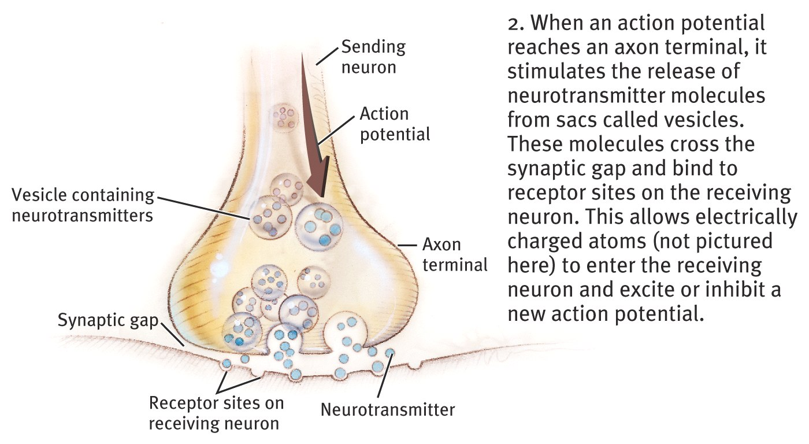
  - Candace Pert and Solomon Snyder (1973) found that morphine binds to receptors in mood/pain sensation areas.
  - Endorphins: natural morphine neurotransmitters.

Serotonin pathways Dopamine pathways
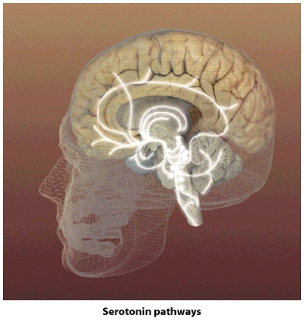
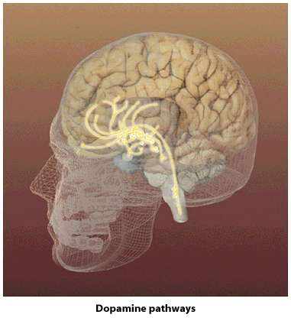

- Neurotransmitter Pathways
  - Serotonin pathways: involved with mood regulation
  - Dopamine pathways: involved with diseases like schizophrenia and Parkinson’s
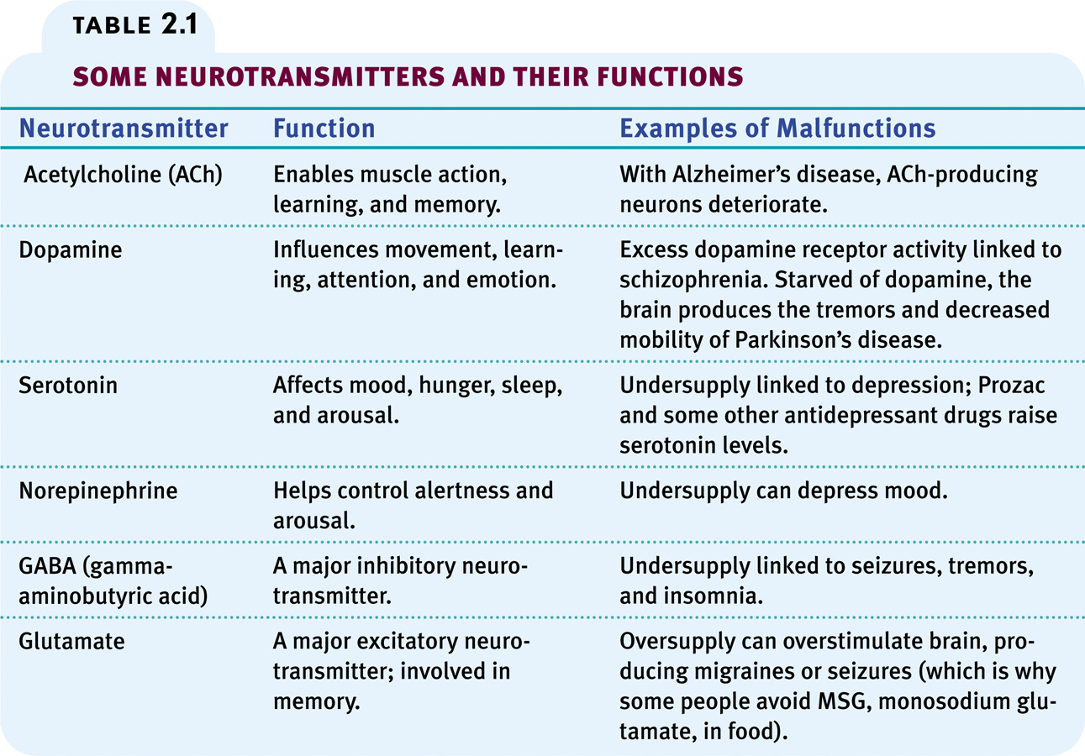
- Lock & Key Mechanism
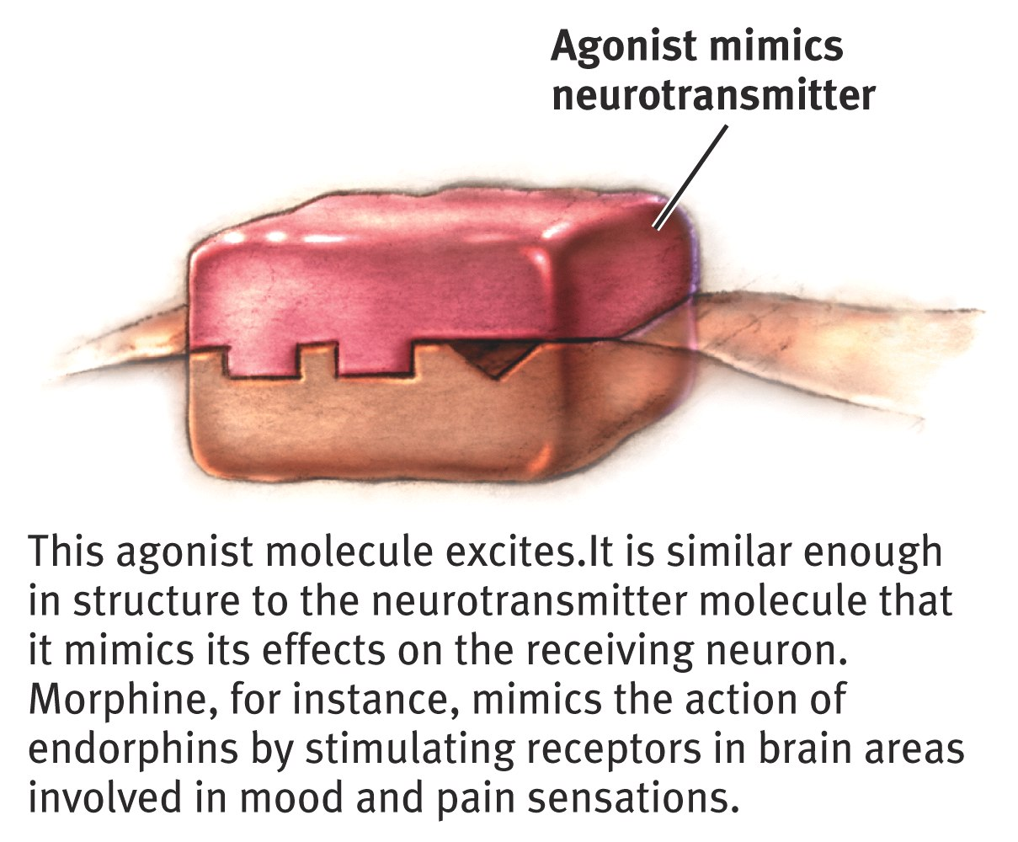
  - Neurotransmitters are keys that unlock receptors of receiving neurons.

  - Agonists:
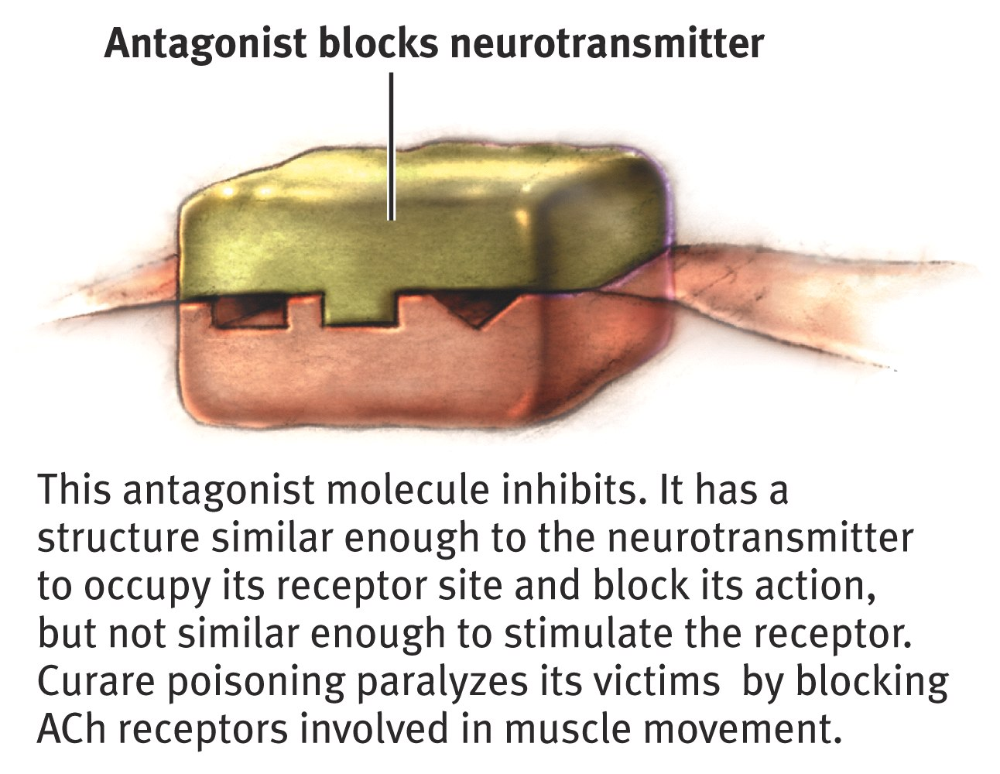
Or could block reuptake

- Antagonists:

- Nervous System: body’s electrochemical communication network. Consists of all nerve cells.
  - Central nervous system (CNS): brain and spinal cord.
  - Peripheral nervous system (PNS): sensory and motor neurons that connect CNS to rest of body.
  - Nerves: bundled up axons that carry the PNS info. Connect muscles, glands, and sense organs to the CNS. Part of the PNS.
- 3 Types of Neurons
  - Sensory neurons: carry incoming sensory receptor info to the CNS.
  - Motor neurons: carry outgoing info from CNS to muscles & glands.
  - Interneurons: connect the other two. Way more interneurons than sensory and motor combined.
- Peripheral NS: has two components: somatic and autonomic.
  - Somatic nervous system: enables voluntary control of body’s skeletal muscles.
  - Autonomic nervous system: controls glands and organs.
- Autonomic NS: dual system.
  - Sympathetic nervous system: arouses the body, mobilizing energy in stressful situations. Ex. sweating when nervous.
  - Parasympathetic nervous system: calms the body, conserving energy. Ex. lower heart rate.
- Central Nervous System
  - Spinal cord is info highway connecting the PNS to the brain. Only way brain receives info.
  - Reflexes: automatic responses to stimuli. Simple spinal reflex pathways have one sensory neuron and one motor neuron with (usually) an interneuron. Other pathways enable pain reflexes. Ex. hand touching a hot pan, neurons get excited by the heat, sending sensory neurons to interneurons in spinal cord. They activate motor neurons to the muscles in arm, jerking away on its own rather than choice. This pathway ran through the spinal cord and out, so it didn’t happens before your brain knows.
- Brain and Neural Networks
  - Neural networks: groups of interconnected neurons that modify with growth and experience. Why grouped together and not spread out? Bc they can have short, fast connections.
- Endocrine System: body’s “slow” chemical communication system.
  - Its glands secret hormones, chemical messengers, into bloodstream.
  - Like nervous system: both secrete molecules that activate receptors. Unlike: slower but usually outlast effects of a neural message.
- Pituitary Gland: “master gland.”
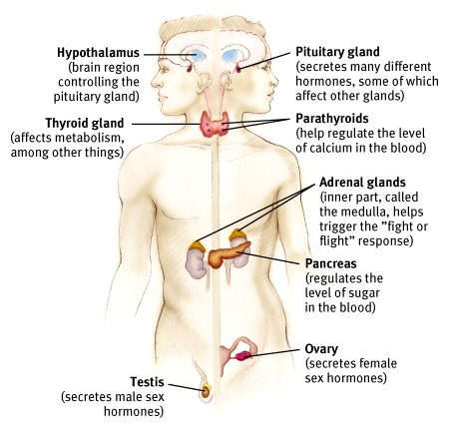
  - Pea-sized in core of brain, anterior lobe releases hormones that regulate other glands and posterior lobe regulates water and salt balance.

Medulla secretes epinephrine and norepinephrine during stressful situations.
Cortex regulates salt and carb metabolism.

Gonads: sex glands. Regulate bodily dvlpmnt and maintain reproductive organs in adults.
- The Brain

